27.18: a) 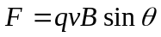
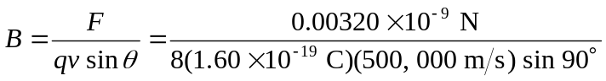
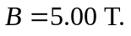If the angle is less than 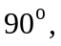 a larger field is needed to produce the same force. The direction of the field must be toward the south so that 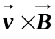can be downward.
b) 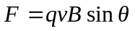
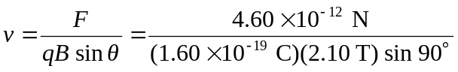
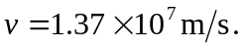If is less than the speed would have to be larger to have the same force. The force is upward, so 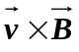must be downward since the electron is negative, so the velocity must be toward the south.

